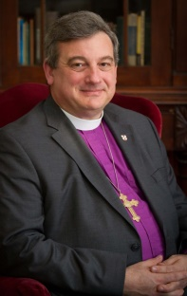 The Rt. Rev. Michael Oulton was installed as the twelfth Bishop of Ontario on September 11, 2011. Bishop Oulton holds degrees from Wycliffe college (DD 2012) (MDiv 1992), The University of New Brunswick (LLB 1985) and Mount Allison University (B.A. 1981).
Prior to entering the priesthood, Bishop Oulton was a practicing member of the Bars of Nova Scotia and New Brunswick. He has served as a member of Municipal Council in his hometown of Port Elgin, New Brunswick to hold elected public office. During his incumbency in Alberton, Prince Edward Island, Bishop Oulton chaired the not-for-profit company “ERC Concepts Ltd.”, a broad coalition of Churches with public and private agencies brought together to construct and enriched residential care facility for seniors. The twenty four unit Rev. W. J. Phillips Residence opened in 1998.
Bishop Oulton’s ministry in the Diocese of Ontario, until his election as bishop on February 12th, 2011, included serving as Regional Dean of Hastings, Chairperson of the Stewardship and Congregational Development Committee, Member of the Strategic Plan Implementation Committee, Diocesan Resource Person appointed under the Sexual Misconduct Protocol, Member of the sub-committee on canons tasked with the development of drafting a revised sexual misconduct policy for the Diocese and member of Synod Council. He was appointed a Canon of the Cathedral Church of St. George, Kingston, in 2004, and served as a delegate to General Synod 2007.
Bishop Oulton cites a passion for the Churches’ engagement with the world in the mission, quoting theologian Thomas Buechner who wrote that our vocation as disciples of Jesus Christ is found where “your greatest passion meets the world’s greatest need.”

