SEC Environmental Report

November - December 2018

Climate Leadership from Faith Leaders at COP24

Prepared for bishop mary
anglican diocese of montreal
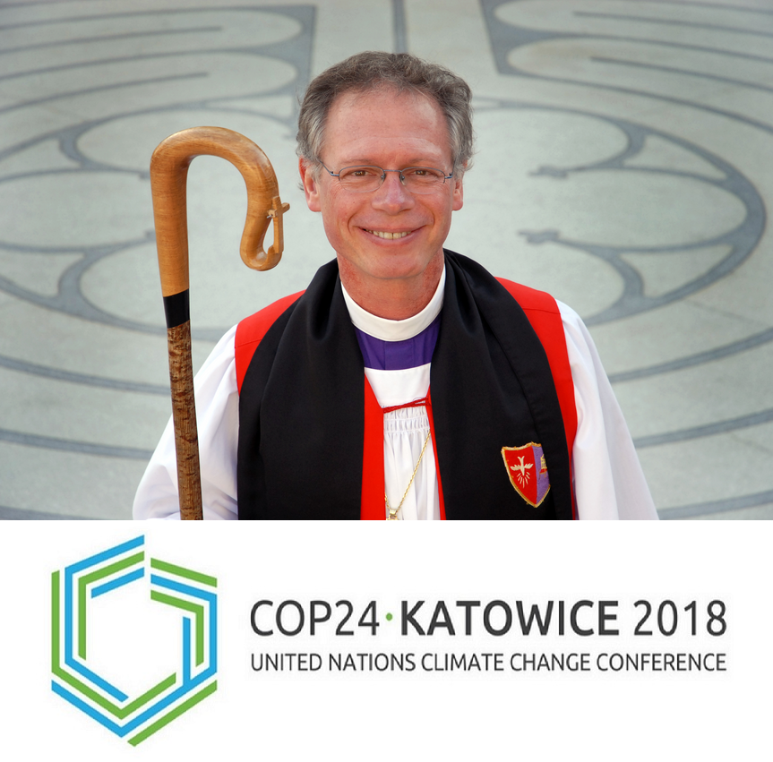
Prepared by Richard Matthews
Chairperson of the SEC
January 5, 2019
No. 4

"As followers of Jesus we care for God's world because God cares for God's world. This means that we care about climate change...God bless our hands as we strive to be faithful in his holy and important work"
Most Reverend Michael B. Curry, 27th presiding Bishop and Primate, The Episcopal church.

This is the SEC's fourth quarterly report for Bishop Mary. This concise report is consistent with the revised SEC mandate and it contains a brief review of our activities, and concise environmental news summaries. After a quick review of the SEC’s efforts we explore climate advocacy from faith leaders. We review the climate advocacy of Christian bishops at COP24. We also review how climate change is part of preparations being made by Anglican bishops ahead of Lambeth 2020.
Review and plans
The video series remains the focus of the SECs efforts in the fourth quarter of 2018. We have a final version storyboarded and we are ready to begin shooting this spring. We have added to the series of posts that will accompany and elaborate on the contents of the video. It is titled The SEC’s Eightfold Path of Environmental Action. This series of posts is designed to help people understand and engage in environmental action. These posts will be published monthly taking us to the launch of the video in 2019.
1. Right Understanding: Knowing the facts about climate change
2. Right Thought: How we think about the natural world
3. Right Speech: Effective environmental communications
4. Right Action: Making smaller footprints
5. Right Livelihood: Work that benefits the planet
6. Right Effort: Choosing a cause
7. Right Concentration: Staying focused on nature
8. Right Mindfulness: Managing climate stress

Climate Advocacy and Christianity
Canadian climate scientist Katharine Hayhoe believes that accepting the facts about climate change is entirely consistent with being a Christian. She is an atmospheric scientist who is the director of the Climate Science Center at Texas Tech University. Hayhoe co-wrote the book called, "A Climate for Change: Global Warming Facts for Faith-Based Decisions," with her husband who is an evangelical pastor.
Hayhoe currently lives in a part of Texas where climate denial is the norm. She explains that the objections to climate science she encounters are political and not theological.
"If you look at the Bible, it says very clearly that humans have responsibility or stewardship or even dominion over the planet...Also the Bible talks a lot about caring for people who are less fortunate than us, people who are vulnerable and poor. That's why I care about a changing climate, because those are the people who are disproportionately affected."
She responds to two of the most common contrarian arguments put forward by Christians. The first is the belief that climate change is not a problem because God is in control, the second is the belief that the world is going to end anyway so it really does not matter.
In response to the "God is in control" argument Hayhoe points to Genesis chapter one verse 26 in which God gives us dominion over the earth. "And God said, Let us make man in our image, after our likeness: and let them have dominion over the fish of the sea, and over the fowl of the air, and over the cattle, and over all the earth, and over every creeping thing that creepeth upon the earth."
Nor does she countenance eschatologists who say, "The world's going to end anyway so why does it matter?" She quotes the apostle Paul in Thessalonians 2 where he essentially says don't sit around waiting for the end to come, do something for those in need.

The advocacy of Christian bishops and other faith leaders at COP24
"God wants us to be stewards for the whole ecological weave, for our shared home, for the oikoumene"
- Swedish Archbishop Anders Wejryd, president of the World Council of Churches (WCC) at COP24
Faith groups advocated for climate action to protect the most vulnerable at the 24th Conference of the Parties (COP24). The most recent United Nations Framework Convention on Climate Change meeting was held in Katowice, Poland from December 3 - 14. The goal of the meeting was to hammer out a framework for implementing the Paris Agreement. This meeting was attended by government officials, subnational leaders, CEOs, the leaders of nonprofits, and faith-based organizations.
In preparation for COP24, six Bishops signed a document and issued a joint statement demanding that global leaders act on climate change. They urged world leaders to take concrete steps "in order to tackle and overcome the devastating effects of the climate crisis."
These 6 bishops represent episcopal conferences on five continents. The statement was signed at the Vatican on October 26, 2018 by: Cardinal Oswald Gracias of Mumbai, India, president of the Federation of Asian Bishops' Conferences; Archbishop Jean-Claude Hollerich of Luxembourg, president of the Commission of the Bishops' Conferences of the European Union; Archbishop Gabriel Mbilingi of Lubango, Angola, president of the Symposium of Episcopal Conferences of Africa and Madagascar, Cardinal José Luis Lacunza Maestrojuan of David, Panama, president of the Latin American bishops' council's economic committee, Cardinal Angelo Bagnasco of Genova, Italy, president of the Council of Bishops' Conferences of Europe; and Colombian Cardinal Rubén Salazar Gómez of Bogota, president of the Latin American bishops' council, also known as CELAM.
Gracias told journalists that on the issue of climate change, the church cannot rest until "the Paris agreement is fulfilled, adhered to and followed up…People who are affected most are the weakest," he said. "There is no doubt that this is something that is urgent, important, and it is our responsibility to throw our full weight on it."
Hollerich said that a contributing factor to the crisis was the flow of money into industries that contribute to climate change, especially fossil fuels.
"If you do not look to the sources of money and where the money flows we have a very nice way of speaking, but things will not really happen," the archbishop said. "And things have to happen because everything is interconnected as Pope Francis says in Laudato Si' and we are responsible for the people in Europe but also the people of other continents...We are co-responsible for this earth, there is only one. We have to act now and I think the urgency of this call is very important."

Episcopal church
Episcopal Bishop Marc Andrus also advocated for climate action at COP24. Bishop Marc Andrus represents the Presiding Bishop and Episcopalians.
“Not only have all the nations of the world signed the Paris Agreement, I have seen the great religions of the world and the indigenous spiritual traditions also come together to seek the healing of the planet,” Andrus said in an email to Episcopal News Service.
Andrus led an eight-member delegation representing Presiding Bishop Michael Curry at COP24. This is the fourth Episcopal delegation to attend the annual conference on climate change. The Episcopal Church began attending the conference in 2015 in France, where the Paris Agreement was reached.
The Episcopal delegation made a spiritual case for climate action that contributed to the signing of an historic accord to reduce greenhouse gas emissions. Since then US president Donald Trump announced that he was withdrawing the US from the agreement. The "We Are Still In" movement has countered this decision in the US and more than 200 faith organizations are signatories.
This crisis concerns everybody and as many people as possible should be involved in finding solutions.
"I have quoted many times in the past decade something that was said by the former archbishop of Canterbury, Rowan Williams: ‘It takes a global body to deal with global problems.’ An example of how this is true is the increasing crisis of environmental refugees," Andrus said referring to the caravan of refugees from Central America seeking asylum in the U.S. "The struggle of the people in the caravan is transnational, and I would say cannot be ‘solved’ by any one country. We must work together for the good of all," Andrus said.
Environmental justice is one of the Episcopal church’s three main priorities, along with racial reconciliation and evangelism. Over the years, the General Convention has passed numerous resolutions on the issue, whether supporting federal climate action or pledging to mitigate the church’s own impact on the environment. The church’s 79th General Convention met in July in Austin, Texas, and passed 19 environmental resolutions, including support for a national carbon tax, carbon offsets for church-related travel, ocean health and Episcopalians’ continued participation in the Paris Agreement.

Eastern Orthodox Church
Archbishop of Constantinople and Ecumenical Patriarch, the primus inter pares in the Eastern Orthodox Church wrote a letter to those in attendance at COP24. Ecumenical Patriarch Bartholomew said the "Time for reflection and deliberation is long gone...We wonder when the leaders of our world will realize how late we have left our response to the climate crisis...A few years ago, we wrote of reaching a point of no return. This was neither euphemism nor exaggeration. Scientists have long warned that we have reached several tipping points; governments seem reluctant to respond, preferring to delay...In order to restore the planet, we need a spirituality that brings humility and respect with regard to our attitudes and actions, our life choices and lifestyles...The truth is that we can no longer afford to wait, indecision and inaction are not options. Faith makes it clear that we have a choice. The time to choose is now".

Catholic Church
Msgr. Bruno-Marie Duffé, head of the Holy See delegation at COP24, repeated Pope Francis' call to listen to the cry of the Earth and the cry of the poor, he urged a renewal of global solidarity on the part of nearly 200 governments to their commitment to the address the "social crisis" posed by climate change through the goals outlined under the Paris Agreement. "We have to pass from the ethical intentions about climate, about the future of life on this Earth, to financial and political decisions," the monsignor said. In an interview with NCR, Duffé said, "I feel a gap between the urgency" in terms of the decisions the conference must make and the commitment of some delegates, naming specifically Russia and Saudi Arabia.
At one point in his remarks, Duffé said, "We have to encourage the scientific community, especially reading and considering" the latest Intergovernmental Panel on Climate Change report.
On Dec. 10, the Pontifical Academy of Sciences hosted scientists and faith leaders at a daylong event on climate research and ethics, with Patricia Espinosa, executive secretary of the U.N. Framework Convention on Climate Change, in attendance.
In a Dec. 12th speech, former U.S. vice president and prominent climate activist Al Gore said, "The rising generation is demanding a better world," and he called climate change "the single most important moral choice that humanity has ever faced." He referenced Francis' teachings in the 2015 encyclical "Laudato Si', on Care for Our Common Home" about the poorest and most disadvantaged suffering the greatest impacts of climate change. "We've got public support [for climate action] all over the world," Gore said. "We have the technologies. We have the solutions. We have the moral mandate”.

A Catholic Nun on the Need for Change from Within
Joan Chittister is a Catholic nun who wrote about the growing trend of climate advocacy from religious leaders. In an NCR piece she recounted how she was among a diverse group of religious leaders that attended COP24. Chittister wrote that the religious groups in attendance at COP24 know that "nothing much can happen to the world around us until something happens within us that is beyond money and power, that seeks global harmony and world peace".
Chittister and other religious leaders spoke about, "spiritual development as the key to human development, the need to understand that we are here to complete the work of creation rather than consume it".
Chittister said:
"From where I stand, it seems to me that the scientific data won't mean much, then, until we stop again to examine our core values, our sense of what it means to be fully human, our attitudes about what makes for a full life, a happy life, a moral life. Until we each make a connection between how we live on the Earth, how we see our relationship to it as a measure of our morality, it is doubtful that much will happen to save it. At the end of the day, we simply need to decide what kind of person we want to be on a globe that is crying out in distress."

Should Faith Leaders be Climate Leaders?
In a recent BBC broadcast, Ruth Valerio discussed the role of religions and faith leaders in efforts to address climate change. Valerio is an Environmentalist and theologian, social activist and author. She is also the Global Advocacy and Influencing Director at Tearfund, a Christian charity focused on ending poverty. They work through local churches to unlock people's potential.
Valerio states that Christians and other faith leaders are well positioned to promote climate action. "I think faith communities all around the world have a huge part to play. Faith leaders are uniquely placed to be able to support and motivate communities all around the world. They can help their members to take actions both individually and also holding governments to account."
When asked if she thought the church had a responsibility to divest from environmentally irresponsible investments, she said, "we have actually been seeing a big move in that direction," she pointed to the Church of England's "massive steps" through the Transitions Pathway Initiative (TPI). She also said: "Many other denominations in the UK and elsewhere have been taking those steps to signal to the fossil fuel companies that the situation is serious and we need to change."

Preparing for Climate Action in the Anglican Church
Climate action was among the issues discussed at a recent Primates meeting in Toronto. Primates including host Fred Hiltz gathered in Toronto with Anglican leaders from the Americas and the Caribbean to prepare for Lambeth 2020.
The Archbishop of Canterbury has invited all bishops of the communion to attend the Lambeth Conference in 2020. The theme is, "God’s Church for God’s World". The primates asked, "that our reality be made a priority," this includes the issue of climate change.
Anglican Archbishop and Primate Fred Hiltz wrote, "Those in attendance discussed their hopes and expectations and they identified a number of concerns, including concern for our common home, the earth itself".
Archbishop Hiltz reflected on Jesus words: "This will give you an opportunity to testify" (Luke 21:13), and he invited his colleagues to consider what their own testimony "is and ought to be". He said that, "episcopal leaders in our worldwide Anglican Communion...know we face pressing global issues that bind us together and require us to speak out and to be one in facing them."
He then asked, "When we are faced with a choice to either remain silent or to speak out for justice in the name of Christ...Will we speak out too protect the children of the world? Will we stand with Indigenous peoples across the globe? Will we with the poorest of the poor? In a world where unjust political and economic policies give wealth and power to a very few and heap upon hardship on so very many, what will our testimony be? What will we say about gender-based violence, the crime of trafficking human beings for the sex trade and other forms of exploitative labour, the refugee crisis, and climate change? What will our testimony be? How will it take shape? How will it be fleshed out?"
Poignant testimony of children at COP24
Joseph Sapati Moeono-Kolio, a Samoan observer at the Synod of Bishops and a member of Caritas Internationalis, explained that his support for the Bishop’s document delivered at COP24 is about children. "[Y]oung people bear the brunt of a lot of bad decisions and we want to end it here, Sapati Moeono-Kolio said. “I think that's a very good image of what we're trying to do here, the importance of this document, the church now should be a haven of safety, especially for young people".
Fifteen year old Greta Thunberg delivered two powerful speeches at COP24 that were both a chilling rebuke of our inaction and a haunting warning. Greta spoke truth to power and like a ghost from Charles Dickens' 1843 novella, A Christmas Carol she showed us what we have done, what we are doing and what we must do to redeem ourselves. She cuts through our excuses and exposes the insanity of our failure to do what common sense dictates we must. Here are some excerpts from the speeches she delivered at COP24:
“You are not mature enough to tell it like it is. Even that burden you leave to us children…Our civilization is being sacrificed for the opportunity of a very small number of people to continue making enormous amounts of money. Our biosphere is being sacrificed, so that rich people in countries like mine, can live in luxury. It is the sufferings of the many which pay for the luxuries of the few.”
“You say you love your children above all else, and yet you are stealing their future in front of their very eyes…We have run out of excuses, and we are running out of time. We have come here to let you know that change is coming, whether you like it or not. Because we are facing an existential threat and there is no time to continue down this road of madness. We already have all the facts and solutions.”
“We have come here to let them know that change is coming whether they like it or not. The people will rise to the challenge. And since our leaders are behaving like children, we will have to take the responsibility they should have taken long ago. “

Remembrance Day
A concluding thought on Remembrance Day which took place on November 11th. As we remember soldiers who made the greatest sacrifice, surely there is something we can learn from past generations who sacrificed everything for future generations.

