SAVE THE DATE!
10th Annual Thanksgiving Benefit Dinner: Thursday, October 25th, 2018 at 6 p.m.
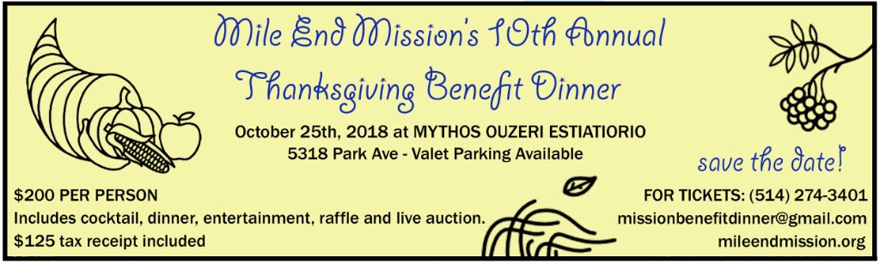
We are excited to announce the Mile End Community Mission’s 10th Annual Thanksgiving Benefit Dinner. This major annual fundraiser helps the Mission continue its essential work providing care, inspiration and hope to those struggling well below the poverty line in the Mile End and surrounding areas of Montreal.
Once again this year, we’re holding our Annual Thanksgiving Benefit Dinner in the Mile End neighborhood at the wonderful Mythos Ouzeri Estiatorio, located at 5318 Avenue du Parc. Our choice of this local venue reflects our desire to celebrate Thanksgiving and all of our many blessings within our community.

We look forward to welcoming you for cocktails at 6 p.m. followed by a wonderful dinner at 7 p.m. Tickets are $200 per person and a tax receipt for $125 will be available. The evening will also include a raffle and small live auction with nice prizes and items to bid on.
In the spirit of Thanksgiving, guests will have the opportunity to support our community while enjoying a wonderful evening surrounded by old and new friends of the Mission!
With your support, the Mission will continue to fulfill the needs of an ever-growing number of marginalized individuals and families, offering a safe and caring place where they can always feel welcomed and receive the support they need.
For additional information about the dinner or to request tickets you can call Lou or Lori at the Mission: 514 274-3401 or send us an email at missionbenefitdinner@gmail.com.
Tickets can also be purchased:
- By making a secure on-line payment through our website: http://mileendmission.org/thanksgiving-benefit-dinner-2018
- By sending a cheque to the Mile End Mission at the address above with a note specifying the 2018 Thanksgiving Benefit Dinner
- In person at the Mile End Mission: 99 Bernard West/corner of St. Urbain, Montreal QC, H2T-2J9.

