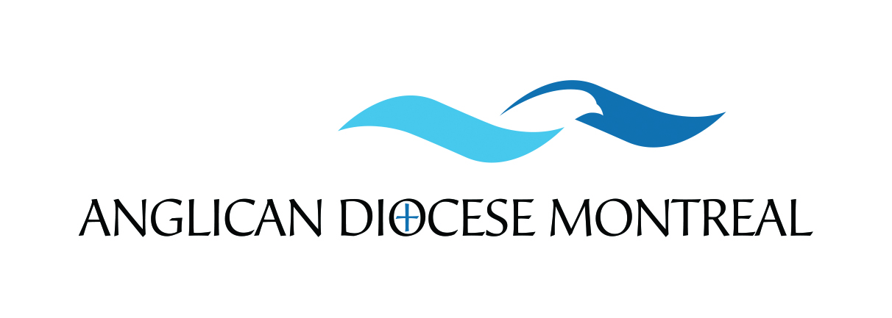

45th CLERGY LENTEN RETREAT

If you choose a Private Bathroom, you will be charged accordingly. See to your right:
REGISTRATION FORM
40th CLERGY LENTEN RETREAT

Registration fees must be paid in advance. Please fill in the form and send it with your payment.

Name:

Do you have any dietary and/or physical restrictions that we should be aware of?
YES: Please explain:

IF YOU CANCEL YOUR REGISTRATION, YOU WILL BE REQUIRED TO REIMBURSE FULL COSTS OF $200 FOR SHARED BATHROOM OR $275 PRIVATE BATHROOM.
REGISTRATION FEES
FIRST COME, FIRST SERVED
Room: Shared bathroom NO CHARGE
Room : Private bathroom $75.00
Room: Dbl.Occ. Private bathroom $170.00 (COUPLES)

PAYMENT METHOD:

CHEQUE

ARRIVAL AND DEPARTURE

Card Number

ARRIVAL

Sunday (dinner required) Sunday (after dinner)

DEPARTURE
(************Tuesday) Tuesday after breakfast Tuesday after lunch

Expiration Date

We encourage you to use funds from your Continuing Education Plan to pay the registration fees; You can find the CEP forms online at www.anglicanpension.ca/for-plan-members/cep/
Note that you must pay your registration fees prior to receiving the refund

I am available: to officiate to assist
from CEP.
If paying by cheque: Make it to the order of: “Diocese of Montreal” .
Mail to:
Diocese of Montreal
Att: Clergy Lenten Retreat (Maria Abate)
1444 Union Ave.
Montreal, QC
H3A 2B8

or by Credit Card (VISA and MASTERCARD ONLY). Fill in form above and email to mariaa@montreal.anglican.ca or mail to above address or fax to 514-843-3221 or call 514-843-6577 Maria Abate xt 235 or Jennifer xt 249.
DO NOT SEND CASH.

