Clergy Conference 2015
September 20th to 22nd, 2015
at Centre Musical CAMMAC, Harrington QC

“Connections”
  - An opportunity to connect with each other and our new Bishop as we begin the next chapter in the life of the Diocese of Montreal!

Short biography of our Facilitator

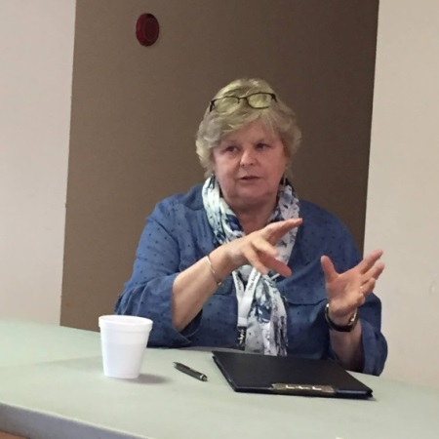
Our facilitator will be The Rev Lynn Uzans: retired Parish Priest, Spiritual Director, Congregational Consultant and Storyteller.

Since retirement as Rector of St James, Kentville, Nova Scotia, Lynn has been offering spiritual direction to individuals and has been helping parishes discern ministry focus. She is currently Vocations Coordinator for the Diocese of NS & PEI, a member of the National (and home diocese) Planning Team for Healthy Congregations Consultations. She does storytelling and storytelling workshops whenever she gets the chance.
Lynn is married to Elmer and is mother of two grown daughters: Drea and Nicole. For fun, she quilts, reads and plays board games.
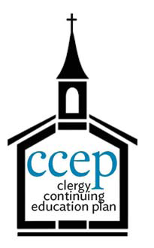

This event qualifies for nine (9) hours in the Clergy Continuing Education Program!
Clergy Conference 2015
September 20th to 22nd, 2015
at Centre Musical CAMMAC, Laurentides (Québec) Canada
85, ch. CAMMAC, Harrington QC J8G 2T2

REGISTRATION FORM

To register, please fill in the form and send it with your payment. Please note that only completed forms accompanied by the total payment will be processed.

Name (Family name, First name):

Arrival and Departure

Arrival
☐Sunday (dinner required)
☐Sunday (after dinner)
☐Other, please specify:
Departure (if before the end of the Conference)
☐Monday morning after breakfast
☐Monday afternoon after lunch
☐Monday evening after supper
☐Tuesday Morning after breakfast

Daily Offices (check if applicable)

☐ Available to officiate
☐ Available to assist

Registration fees
  - We encourage you to use funds from your Continuing Education Plan (CEP) to pay the registration fees; you can find the claim form online at http://www.anglicanpension.ca/forms/.
☒ Residential: $190.00 (including two night-stays, breakfasts, lunches, dinners and snacks)
☐ Non-Residential: $80 (including lunches, dinners and snacks)

PAYMENT INFORMATION
Your payment is payable by cheque to the order of “Diocese of Montreal” or by Credit Card (Visa and Mastercard).
- Please check one box: ☐ Cheque ☐Mastercard ☐Visa

- If paid by credit card, please complete the following:
Card Number:
Expiration Date:

REGISTRATION DEADLINE AUGUST 28th!!!
  - Send form to Ardyth Robinson at arobinson@montreal.anglican.ca

